Data Structures

Lecture No. 30

Reading Material
Data Structures and Algorithm Analysis in C++ Chapter. 6
6.3

Summary
- Inserting into a Min-Heap
- Deleting from a Min-Heap
- Building a Heap

Inserting into a Min-Heap
In the previous lecture, we discussed about the heap data structure besides touching upon the concept of storage of complete binary tree in an array. For the study of parent-child relationship, the ‘2i and 2i+1 scheme’ was used. Then we changed our focus to heap and found it best for the priority queues. In the previous lecture, we did not really discuss the uses of heap. Rather, most of the discussion remained focused on insertion method in the binary tree employed at the time of implementation with the help of an array. After inserting a new element in the array and by moving few elements, a programmer can have minimum or maximum heap. In case of minimum heap, the minimum value in the tree is always in the root of the tree. However, in case of maximum heap, the maximum value in the tree lies in the root node.
When we insert a new element in the tree implemented with the help of an array, we insert element at the last position (of the array). Due to this insertion at the end, the heap order may be violated. Therefore, we start moving this element upwards. While moving upward, this element may reach at the root of the tree. It is important to note that only one branch of the tree is affected because of this movement in the upward direction. This process, being of localized nature, will not disturb the entire tree.

To recap, see the figure Fig 30.1, where we are inserting an element 15.
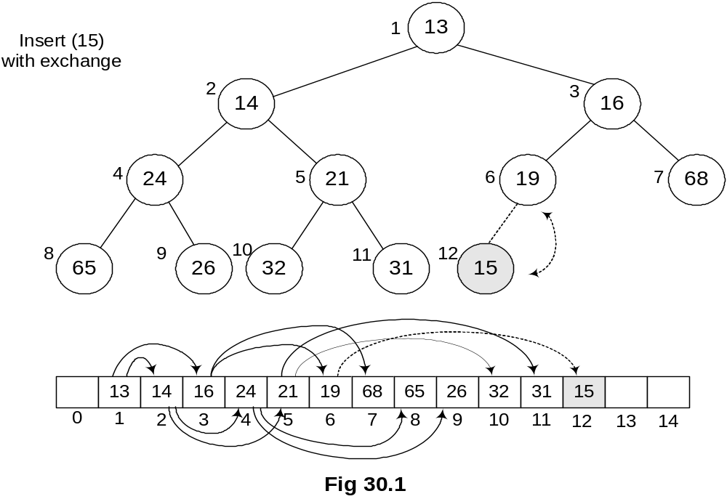
The new element 15 is inserted at the last array position 12. Being a complete binary tree, the next new node will be the left child of node 19. As node 19 is at array position 6 (or level order traversal), its left child will be 6 * 2 = 12th position node or the value at 12th position in the array. Now, we see where we will have to carry out the exchange operation. As the parent of 15, the number 19 is greater than it, the first exchange will be among 19 and 15 as shown in the above figure. After exchange, the new figure is shown in Fig 30.2.
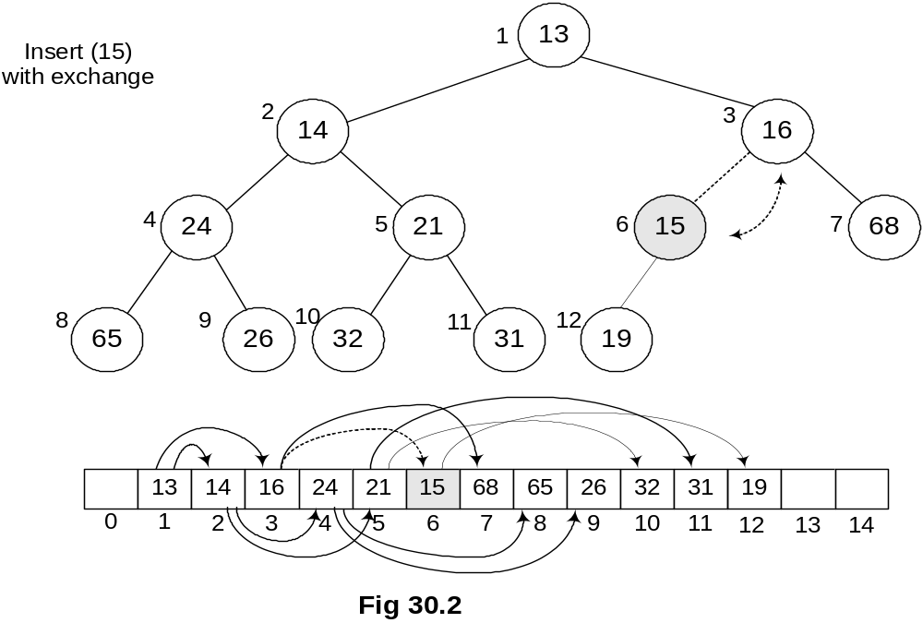
You can see that both the elements have exchanged positions i.e. 19 has come down and 15 gone up. But number 15 is still less than its parent 16, so we will have another exchange operation.
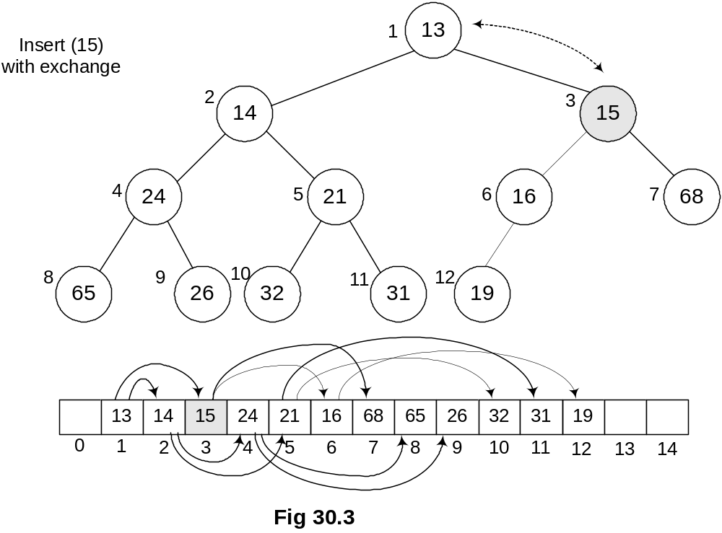

Now the new parent of 15 is 13 which is less than it. Therefore, the exchange operation will stop here as 15 has found its destination in the tree. This new tree is not violating any condition of heap order as witnessed before insertion of 15. It has become min-heap again while maintaining its status as a complete binary tree.
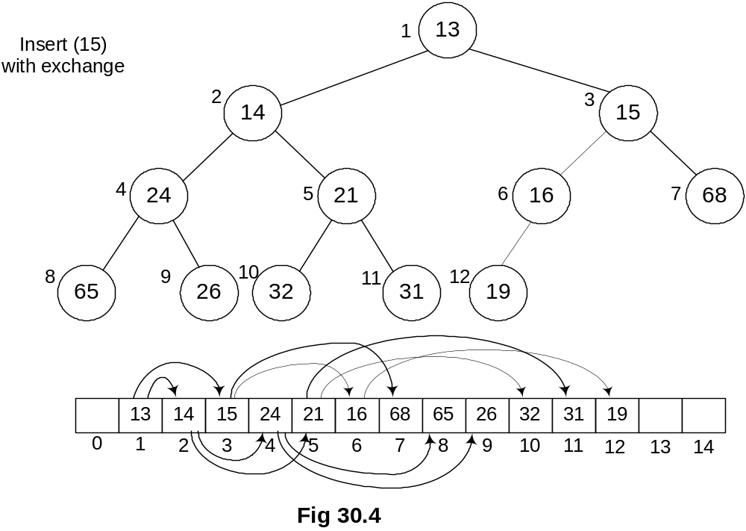

A view of the path shows that the number 15 has gone through to find its final destination in the tree. It has only affected the right sub-tree’s left branch that was containing 16, 19 and 15. It has not affected any other branch. This is not a binary search tree. Here we are only fulfilling one condition that the parent value should be less than that of its two-children. These exchanges will not take long as we did mathematically that a tree containing N nodes; can go to log₂N level maximum. You know, when we built binary tree for balancing, it had turned into a linked list. Here the case is different. the number of levels in complete binary tree will be around log₂N while building a complete binary tree.
Now, we should be clear that a new element can go up to what maximum level in the tree. If the number is greater than all parent nodes, it will be already at its destination place, needing no exchange. If we insert a number smaller than all parent nodes, the exchange operation reaches to the root of the tree. But this exchange operation’s intensity does not increase from the one we saw in our previous case of linked lists.

Deleting from a Min-Heap (deleteMin)
Now, we will see how the delete operation is executed in the heap. We do a lot of insert and delete (removal from the data structure) operations especially when heap is used in the priority queue. Normally the delete operation is a bit complex. However, in this case, it is quite easy-to-do.
We want to write a function deleteMin(), which will find and delete the minimum number from the tree.

- Finding the minimum is easy; it is at the top of the heap.
See the heap below. It is a min-heap. Now the question arises where the minimum number will be lying. It is clear from the definition of min-heap that it should be in the root of the tree. So finding the minimum is very easy.
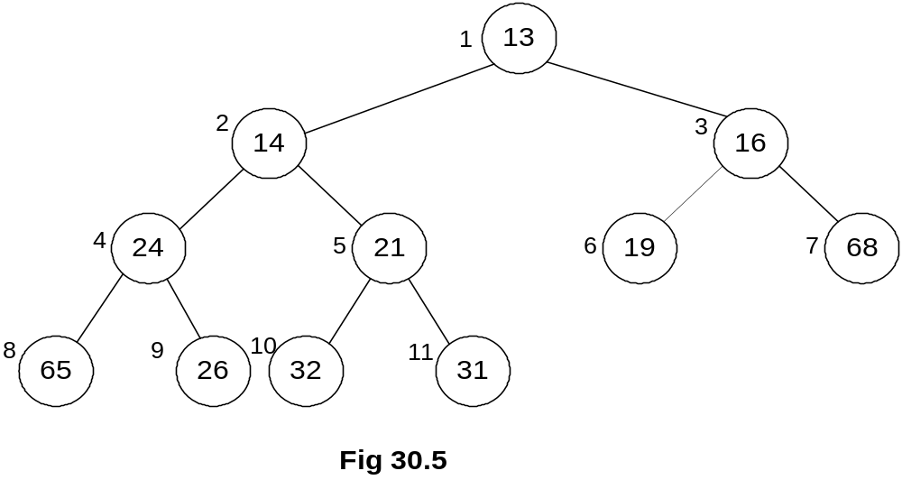

To understand it better, consider the tree form first, instead of thinking about the array. Remember, we have implemented the complete binary tree with the help of an array for the sake of efficiency. It is not necessary to implement it this way. We can also implement it with pointers. However, heap is normally implemented through array.
Coming back to the deletion, it is necessary to understand that
- Deletion (or removal) causes a hole which needs to be filled.

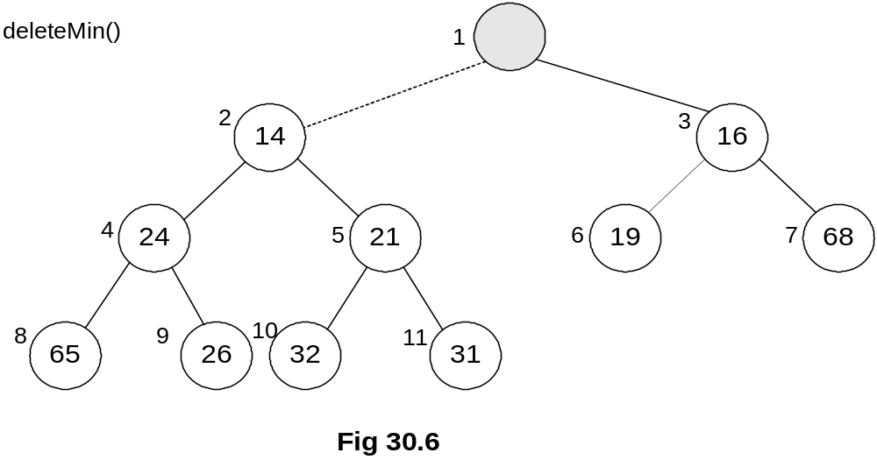
In the above figure, we have deleted the root node, resulting in a hole at the root position. To maintain it as a complete binary tree, we have to fill this hole. Now, we will identify the appropriate candidates to fill this hole. As the parent is the minimum as compared to its right and left children, the appropriate candidates are both right and left children of the root node. Both children will be compared and the smaller one will take the vacant place. In the above figure, the children 14 and 16 are candidates for the vacant position. Being the minimum, 14 will be put in the hole.
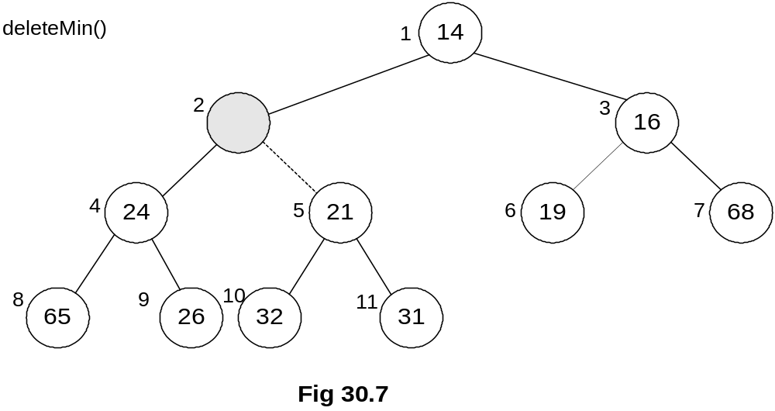

In the Fig 30.7, we can see that the 14 has been placed at the root position. However, the vacuum at the previous position of 14 has created a hole. To fill this hole, the same logic is applied i.e. we compare both right and left children of the hole and let the minimum take over the place. Here 24 and 21 are compared. Being the smaller one, 21 is placed at the vacant position. This way we get the latest figure of the tree as seen in the following figure. (Fig 30.8.)
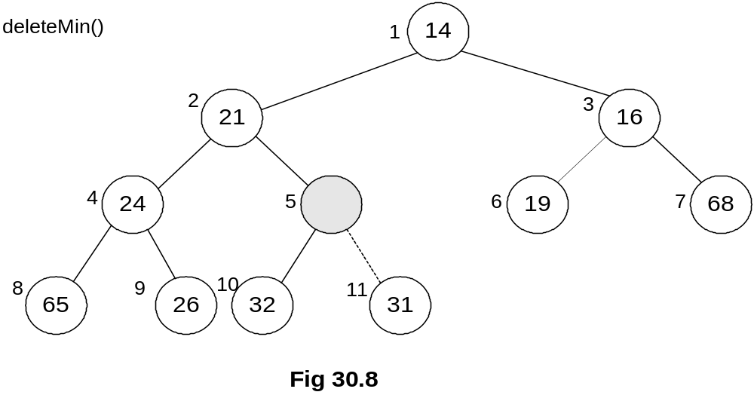

The hole is now created at previous position of 21. This time, the children- 32 and 31 are compared and being smaller, 31 takes over the place and the tree becomes as shown in the figure Fig 30.9.
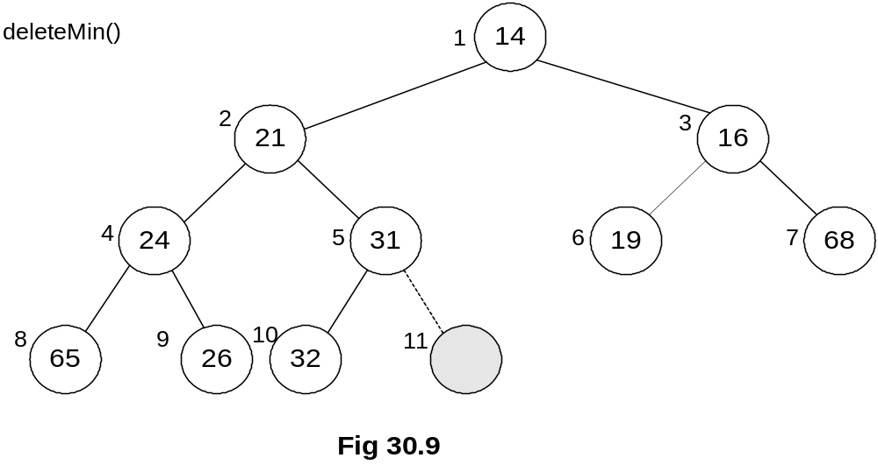

The hole has been transferred from top to the bottom. It has reached at such a position where it can be deleted.
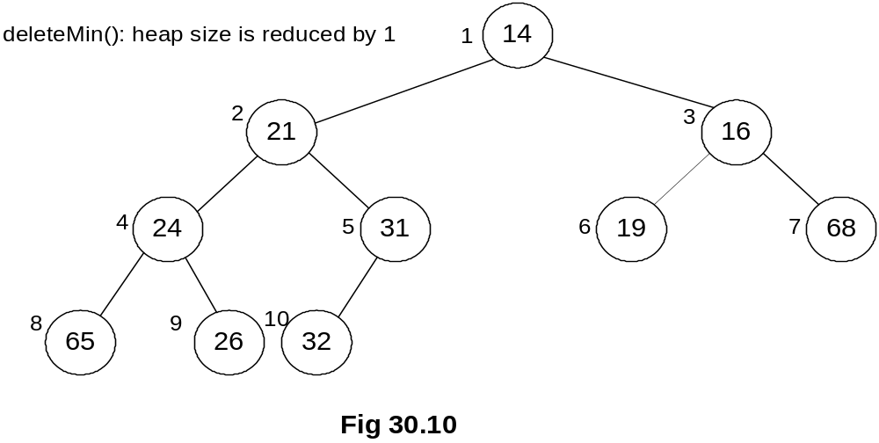

While using array to store complete binary tree, we can free array element at the end. From the above figure Fig 30.10, the last array index 11 is no more there and the node has been deleted.
We saw that the data element was inserted at the bottom of the tree and moved upwards while comparing it with the parents (following the i/2 scheme) until its destination was found. Similarly, when we deleted a node, the hole was produced. While following the definition of min-heap, the hole kept on moving from top to the bottom (following the 2i or 2i+1 scheme).
Building a Heap (buildHeap)
Now, we will see how a heap can be made and in which peculiar conditions, it should be built. We may have the data (for example, numbers) on hand, needed to used to construct the tree .These data elements may be acquired one by one to construct the tree. A programmer may face either the situations. If we consider priority queue, it is normally empty initially. Events are inserted in the queue as these are received. You can also consider priority queue in another application where data can be inserted into the queue or taken out at one time.
Let’s say we have a large unsorted list of names and want to sort it. This list can be sorted with the help of the heap sort algorithm. When we l construct the heap or complete binary tree of the list, the smallest name (considering alphabet ‘a’ as the smallest) in the list will take the root node place in the tree. The remaining names will take their places in the nodes below the root node according to their order. Remember, we are not constructing binary search tree but a min-heap to sort the data. After the construction of the min-heap from all the names in the list, we start taking the elements out (deleting) from the heap in order to retrieve the sorted data. The first element that is taken out would be the smallest name in the heap. The remaining heap after taking out the deleted node will be reduced by one element in size and the next name will be at the root position. It is taken out to further reduce the tree size by one. This way, the continuation of the process of taking out the elements from the heap will ultimately lead to a situation when there is no more node left in the tree.
While keeping in view the time consumption factor, can we find a better way than this? We may change the data structure or algorithm for that. There are data structures which are more efficient than heap. But at the moment, we are focusing the heap data structure. We will see, what we can do algorithmically to improve the performance, having all the data simultaneously to construct the tree.
Following are some of the important facts about building a heap.
- Suppose we are given as input N keys (or items) to build a heap of the keys.
- Obviously, this can be done with N successive inserts.
- Each call to insert will either take unit time (leaf node) or log2N (if new key percolates all the way up to the root).
- The worst time for building a heap of N keys could be Nlog2N.
- It turns out that we can build a heap in linear time.
- Suppose we have a method percolateDown(p) that moves down the key in node p downwards.
- This is what happens in deleteMin.
We have used the word keys in the first point. This is the same concept as that of the database keys, used to identify information uniquely. Using the example of telephone directory (also discussed in a number of previous lectures), we see that it contains the person name (first, middle and last), address (street address, district and postal code) and telephone number. All these information together form a data record. This set of information fields (record) will always be together. The key item here can be the unique name of the person or the telephone number.
Consider that we have N number of items i.e. names. One way is to call insert for every element one by one. For N elements, it will be N number of calls obviously. Being an iterative process, this insertion technique can be executed in a loop fashion.
Let’s talk about the time taken to insert a node in the tree. It depends on the value to be inserted and the values already present in the tree. The number of exchanges can be variable. Therefore, the insertion time is also variable. Each call will be a unit time (in case of leaf node) or log2N (if new key percolates all the way up to the root node). For the whole tree, the worst time for N keys would be Nlog2N.
Next point tells about the possibility of reducing the time from Nlog2N and it can turn out to be a linear time. This is our target and we want to achieve it. Let’s talk about the ways to achieve the linear time.
The word percolate above means something is going upward from downward. This terminology is coming from coffee maker, where the hot water moves upwards. This phenomenon happens at the time of insertion. On the contrary, in delete operation, the hole moves towards the bottom of the tree. You must be remembering that we discussed about insertion in the heap without making exchanges and by finding the destination position first before making any change. Similarly in case of deletion, the hole moves downward while the data moves upwards. Let’s write a method for the delete operation percolateDown(p). This method will find which child of the hole will be moved upwards and the movement of hole to the bottom of the tree.

We will see, using this method, how can we built a heap that will be take lesser time than Nlog2N.

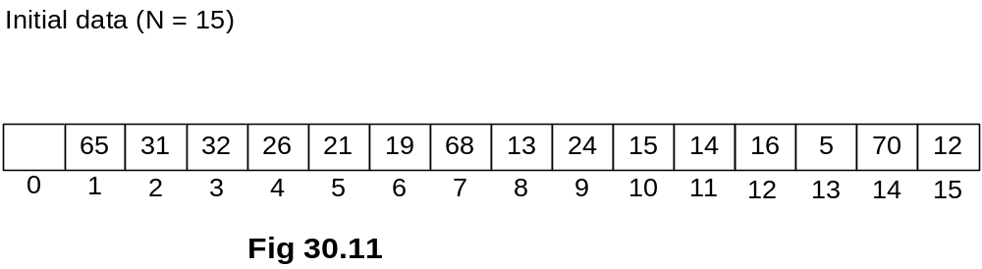

As shown in the figure Fig 30.11, we are given a list of 15 elements and asked to construct a heap of them. The numbers are stored in an array, starting from index (position) 1. This start of array from position 1 is to make the tree construction easier. It will be clear in a moment. Contrary to the previous situation when array was used to store heap or complete binary tree, we should now think what would be the picture of complete binary tree out of it. It may seem complex. But actually it is quite easy. You start from the very first element in the array i.e. the root of the tree. The children of root are present at 2i and 2i+1, which in this case, are at positions 2(1) = 2 and 2(1)+1=3. The children nodes for the node at position 2 are at positions 2(2)=4 and 2(2)+1=5. Similarly, the children nodes for the node at position 3 are at positions 6 and 7. Apply this logic to the whole of this array and try to construct a tree yourself. You should build a tree as given in the figure Fig 30.12.
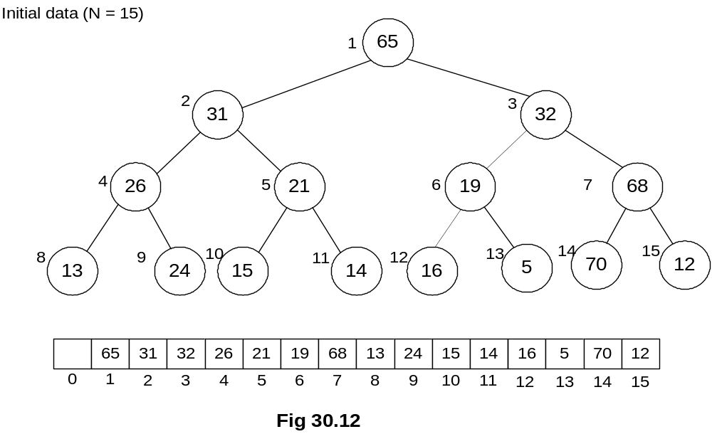

Is this tree binary one? Yes, every node has only two left and right children.
Is it a complete binary tree? It surely is as there is no node that has missing left or
right child.
The next question is; is it a min-heap. By looking at the root node and its children, as the root node is containing 65 and the children nodes are containing 31 and 32, you can abruptly say that no, it is not a min-heap.
How can we make min-heap out of it? We may look for percolateDown(p).method to convert it into a min-heap. As discussed above, the percolateDown(p).moves the node with value p down to its destination in the min-heap tree orders. The destination of a node, can be its next level or maximum the bottom of the tree (the leaf node). The node will come down to its true position (destination) as per min-heap order and other nodes (the other data) will be automatically moving in the upward direction.

- The general algorithm is to place the N keys in an array and consider it to be an unordered binary tree.
- The following algorithm will build a heap out of N keys.

for( i = N/2; i > 0; i-- )
percolateDown(i);
A close look on the above loop shows that it is starts from N/2 position and goes down to 0. The loop will be terminated, once the position 0 is reached. Inside, this loop is a single function call percolateDown(i). We will try to understand this loop using figures.
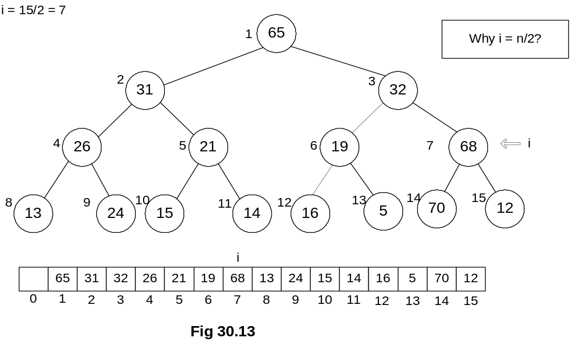

You can see the top left of the figure Fig 30.13. It is given i = 15/2 = 7. This is the initial value of i .The value in the array at position 7 is 68. In our discussion, we will interchangeably discuss array and binary tree. The facts arising in the discussion would be applicable to both. Considering this position 7, we will try to build min-heap below that. We know that for position 7, we have children at positions 2(7)=14 and 2(7)+1=15. So as children of the number 68 (which is the value at position 7), we have 70 and 12. After applying the percolateDown(i), we get the tree as shown in Fig 30.14.
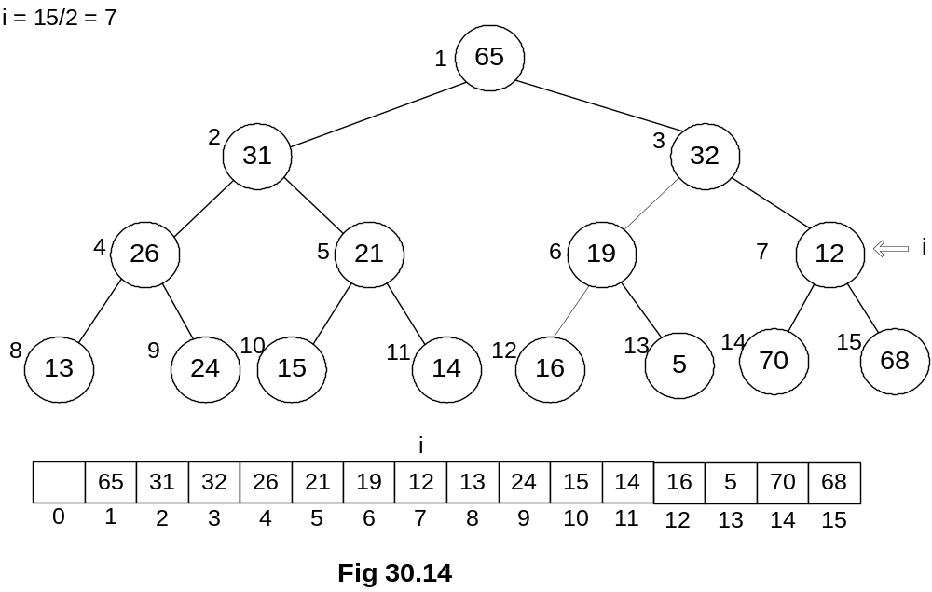

You can see in the figure that 12 has moved upward and 68 has gone down. Now, what about this little tree starting from 12 and below it is min-heap. Surely, it is.
Next, we go for second iteration in the loop, the value of i is decremented and it becomes 6.
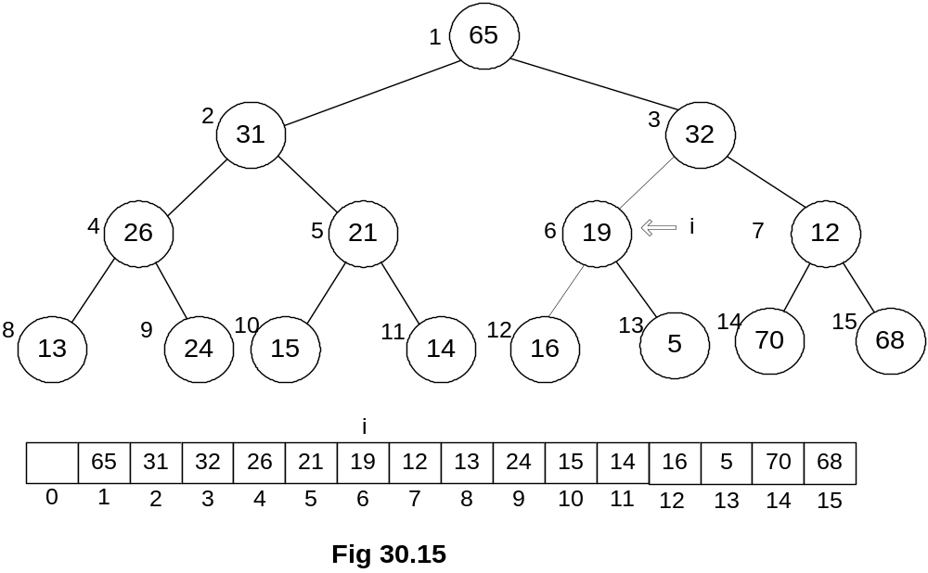

The node at position 6 is 19. Here the method percolateDown(i) is applied and we get the latest tree as shown in Fig 30.16.

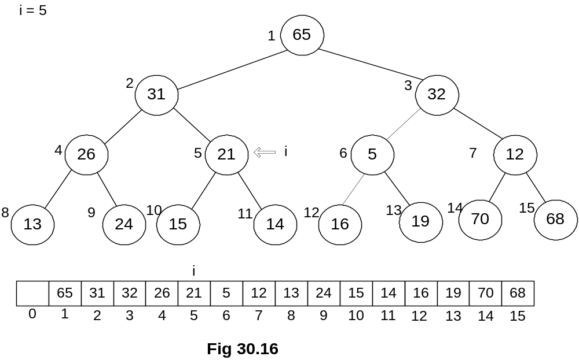

The node 5 has come upward while the node 19 has moved downward. Its value of has decremented. It is now ready for next iteration. If we see the positions of i in the tree, we can see that it is traveling in one level of the tree, which is the second last level.

The question might have already arisen in your minds that why did we start i by N/2 instead of N. You think about it and try to find the answer. The answer will be given in the next lecture. We will continue with this example in the next lecture. You are strongly encouraged to complete it yourself before the next lecture.

